BIO P530/2

Theory

21/2 Hours

Nov. 2024

D+S

BISHOP COMBONI COLLEGE – KAMBUGA

END OF TERM III EXAMINATIONS 2024

**BIOLOGY PAPER TWO (THEORY)**

TIME ALLOWED: 2hours 30Minutes

**INSTRUCTIONS TO CANDIDATES**

This paper consists of two sections; ***A*** and ***B***

Answer **one** question from section ***A*** and any other **three** from section ***B***

Candidates are advised to organize their work and present their answers *logically, coherently and precisely*; illustrating with well labelled diagrams where necessary

**SECTION A (40 MARKS)**

Question 1 is ***compulsory***

1. **Figure 1** below shows the effect of temperature variation on the rates of photosynthesis and respiration of leaves of the same plant. The plant was given adequate amounts of light with other factors kept constant.

**Figure 2** shows the effect of temperature variation on the amount of carbon dioxide absorbed by two plant species; **A** and **B**. Each of these plant species uses a different *carbon dioxide fixation* path way.

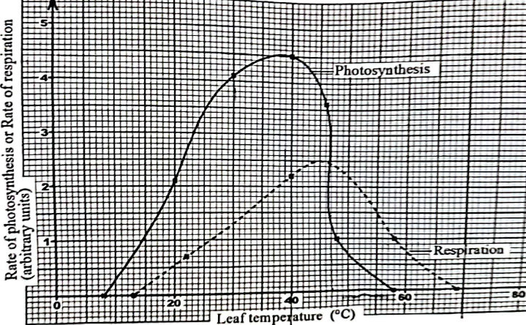

**Fig. 1**

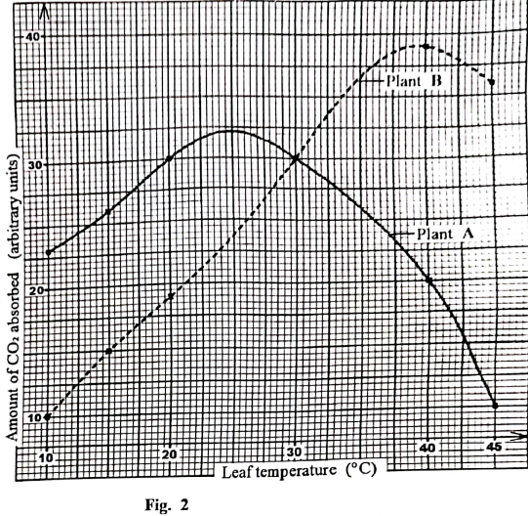

1. From figure 1:
2. Describe how the rate of photosynthesis varies with temperature of the leaf. (*04 marks*)
3. Explain how the rate of respiration varies with temperature of the leaf. (*05 marks*)
4. Explain the difference in the rates of photosynthesis and respiration between leaf temperatures of 40 oC and 70 oC (*08 marks*)
5. Explain the relationship between respiration and photosynthesis. (*04 marks*)
6. Compare the amounts of carbon dioxide absorbed by each of the two plant species A and B in figure 2. (*07 marks*)
7. From figures 1 and 2, suggest the plant species whose rate of photosynthesis was studied in figure 1. *Give reason(s) for your answer*. (*04 marks*)
8. Explain any two other factors that can affect the rate of photosynthesis.

(*04 marks*)

1. Describe how carbon dioxide from the atmosphere is fixed in the bundle sheath cells. (*04 marks*)

**SECTION B (60 MARKS)**

*Answer* **any three** *questions from this section.*

*Any additional questions(s) answered will* ***not*** *be marked*

1. (a) Giving examples, describe the different functions performed proteins in mammals. (*14 marks*)
2. Explain the factors that can cause protein denaturation. (*06 marks*)
3. (a) Describe the structure of the mature vascular tissues in flowering plants.

(*10 marks*)

(b) Explain how the movement of water from the soil provides support in a herbaceous plant. (*10 marks*)

1. (a) Briefly state and explain Mendel’s second law of inheritance. (*03 marks*)

(b) In an oil seed plant species, the allele for tallness is dominant over that for dwarfness. Meanwhile the allele for chlorophyll production and non-chlorophyll show incomplete dominance. The heterozygous plants are variegated.

(i) Using suitable symbols, construct a diagram of a cross between a tall plant with green leaves and a dwarf plant with variegated leaves, to show the genotype and phenotypes of the offspring. (*6 marks*)

(ii) Explain why 25% of the offspring of the cross in (a)(i) would fail to survive. (*02 marks*)

1. In poultry, feather color is controlled by two sets of alleles, **W** [white] dominant over **w** [colored] and B [black] dominant over b [brown] A foul heterozygous for both alleles [**WwBb**] is white.
2. Explain why the genetic constitution of **WwBb** is white? (*02 marks*) (ii) Work out to show the phenotypic ratio of crossing a white cock (WwBb), with brown hen. (*08 marks*)
3. (a) Briefly state what you understand by the term natural selection and show how it occurs (06 marks). (b) Using examples explain how adaptive radiation and homologous structures give evidence for evolution. (14 marks)

6. (a) How are root hairs adapted to function *(06 marks)*

(b) State the forces that prevent the column of water in the xylem from breaking apart when it is pulled upwards

in the trunk of a tall tree *(04 marks)*

1. Explain the role of transpiration in the transport of water from the soil to leaf cells of a tree. *(10 marks)*

***END @TBN***